West Hull Ladies
RRC

West Hull Ladies Marathon Special

First Hull Marathon Involvement
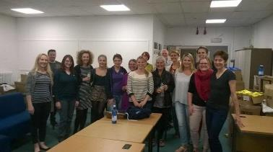
West Hull Ladies packed 1500 Goody Bags … in 2 hours. Awesome!
Marathon Runners
Hull Marathon Results
(790 completed the marathon, 186 ladies)
173 | 1102 | Amanda Dean | Female | 12 | Ages 55-59 | 2/5 | West Hull Ladies | 03:42:16
321 | 249 | Stella Dinsdale | Female | 40 | Ages 65-69 | 1/2 | White City Hull RRC | 04:01:34
394 | 255 | Linda Dodsworth | Female | 55 | Ages 60-64 | 2/4 | West Hull Ladies | 04:13:25
453 | 489 | Jill Jameson | Female | 75 | Ages 50-54 | 7/19 | West Hull Runners | 04:22:44
460 | 698 | Lynne Parkin | Female | 77 | Ages 40-44 | 19/40 | West Hull Ladies | 04:24:29
470 | 62 | Ros Barbour | Female | 79 | Ages 18-39 | 35/90 | West Hull Ladies | 04:25:19
478 | 890 | Tracy Toner | Female | 82 | Ages 45-49 | 11/24 | West Hull Ladies | 04:26:16
661 | 267 | Elizabeth Draper | Female | 138 | Ages 18-39 | 66/90 | West Hull Ladies | 05:00:16
662 | 266 | Jan Draper | Female | 139 | Ages 50-54 | 13/19 | West Hull Ladies | 05:00:18
748 | 609 | Barbara Miller | Female | 173 | Ages 60-64 | 4/4 | West Hull Ladies | 05:31:44

West Hull Ladies Marathon gallery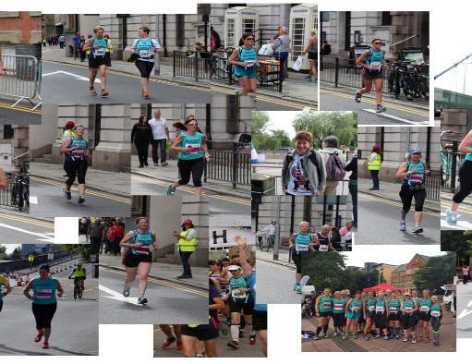

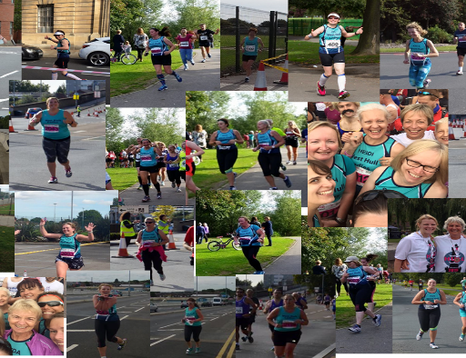

Lynne "My First Marathon"
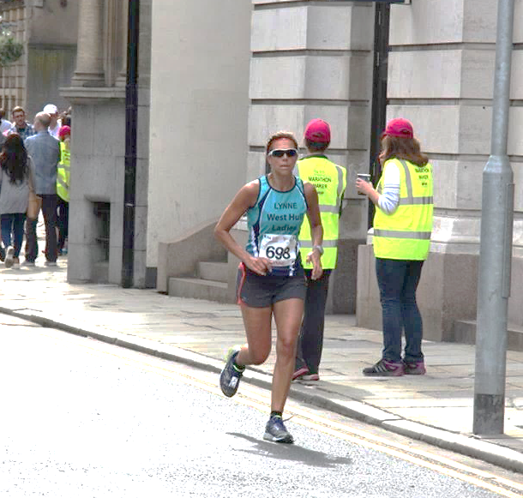
- Training Plan: Follow one! Pick one that suits you and then realise that in 2 months’ time, it doesn’t suit you at all especially during Summer months (see section 5 below). You will find yourself entering every race that is available to cover your shorter runs and then as your runs get longer it will be so that you can avoid having to think up running routes that cover 15, 17.5 & 20 miles. Being 0.2 of a mile short is serious stuff.
- Running Partners: Invite all and sundry to join your race and then find as many as possible to train with but see section 5.
- Weather: you will learn to love running in the rain and you might not mind wind but sun will become your enemy from about week 13 onwards apart from the tanning element!
- Sweat: Yep and smell like a pit pony as well!
- Social Life: Forget it! Unless you are prepared to either change all your weekend plans OR run 4 straight nights on the trot so that you can have two nights for socialising and two nights of rest. Also preferable to socialise with someone who is also running a marathon as you start to sound like a broken record. Eating out becomes a nightmare – see section 9.
- Sports Apparel: You will become fanatical about what you are wearing on race day and will spend hours trying new stuff on and running in it and different trainers only to find various problems before you find the right gear – see section 7 & 8 below.
- Chafing: Inevitable - deal with it then get over it. Elizabeth Ardens 8 hour cream is miles better than Vaseline as it repairs whilst you are wearing it!
- Trainers: 3 different pairs unfortunately! Thank God for sportsshoes.com!!
- Diet: You will become obsessed with food. You will learn and know more about simple and complex carbs than a Sports Science Consultant and you will have great pleasure in telling people about food make up. However this will cause problems when Section 5 co-incides. You will become boring from lack of alcohol and you will gain about 4lbs due to your long runs being more carb loaded. You will learn all about your stomach tolerances to gels and potions and other foods and your body will not hesitate to tell you how much it hates being jigged about for 3 – 4 hours at a time … be warned, if can turn nastyl!
- Other Exercise: Speed work – keep it up, it really helps. Also, if you have time do leg weights and some other cardio but refer back to section 5 and re-juggle your plan for the 14th time.
- Toe Nails: Seriously once painted, who cares what they look like underneath or if they even exist at all.
- Physio: Absolute necessity even if it’s just for a sports massage once a month
- Other Half: yes they go through it with you….Him or her will think you have turned into the ice queen bitch from hell. You will snap at the slightest mention of going out (see Section 5 & 9) and re-arrange your plan for the 20th time. Best to try and be amicable, then throw a tantrum in private. On the plus side just before your race you will be so high on adrenaline you will be doing housework at the most alarming rate ever, even at 1a.m and other delightful household chores.
- Leading up to Race Day: Carbs and more carbs but not excessively – it’s fuel / glycogen that you need not simple sugars (see section 9!!). Lots of water the day before.
- Race Day: Before…Decent breakfast, Ibuprofen, Immodium, Buscopan, Deep Heat, strapping tape, lots of toilet breaks. During… gels, shot bloks, energy drinks, water, more Ibuprofen and Jelly Babies. After race …..banana, pistachios, olives, 2 cans of Guinness, then a strapping cooked dinner and a large glass of red followed by Biofreeze and more Ibuprofen, rest and sleep!
- Aftermath: The John Wayne / Thunderbird walk, Constant food cravings and hunger pangs, itching to run but need to rest. (Have two other races entered already, way in advance, so that I know I can start training again in the next 2 weeks).
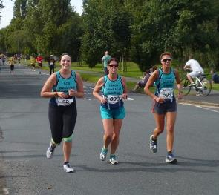

- Reflection: Amazing running partners Ros & Tracy, thank you! Feel very proud but think I could have done it better. Enjoyed it all, wish it was cooler weather, wish I hadn’t done a million and one things and wished I had done some other things. But now I know for next time….did I just say that!!!!

Linda "Hull Marathon"

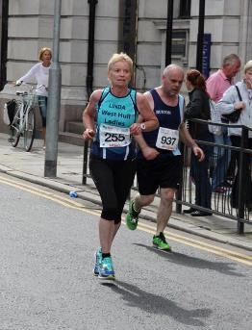
I was thrilled when we found out they were doing a marathon in Hull. I had to enter, it would have been rude not to! It’s not often you can get to a marathon without travelling a fair distance.
16 weeks (well 13 really), of hard training later and the day arrived. Liz (such a lovely girl), came from the town centre where she lives to pick me and Jan up from my house then drive back to town. Thank you Liz. Arrived in Queens Gardens to find our lovely ladies, we do stand out in our new vests so you can’t really miss anyone. The usual queue for the toilets then finally making our way to start.

There was a few of us stood together at the start, I was nervous but very excited too. This is only my second marathon and I didn’t know what to expect. Finally we were off. I tried to get myself into a nice steady pace I didn’t want to burn out! I felt fine and I was enjoying running without having to watch out for cars and seeing so many people who had come out to support was amazing. The first WHL supporter I saw was Maria outside the railway station on Anlaby Road as she was catching a train later on in the day to visit her new Grandson. Thanks Maria, I needed your enthusiasm. Along Anlaby Road I came across Rachel C who was running her leg of the relay it was great to give her a little cheer and encouragement. Seeing Sandra on Anlaby Road flyover was great, she’s such a star supporter.
Entering West Park and running behind the stadium was good too as I knew it wouldn’t be long for the WHL water station, great support from everyone on there, thanks ladies, much appreciated. Out of the park and onwards towards Boothferry Road, Jane shouting and cheering at the roundabout then the long slog up towards the Humber Bridge but it was worth it as we saw the Red Arrows coming towards us, an amazing sight, brought on goosebumps!
Approaching the Humber Bridge and just after the toll booths was a Relay tent and the cheers from our ladies on there made me tear up (I know I’m such a softie), but we are known for our loud cheering and encouragement and you girls did not disappoint!
Over the bridge and under and back over, now coming back was the tough bit for me I’m sure it has got steeper since we trained on there! Anyway not to worry well over half way and I still feel ok, although a little tired! There were some more WHL in the Humber Bridge car park as we ran through but I think I was walking at that point as I’d grabbed an energy drink and water and had just taken a gel, thanks for the support girls.
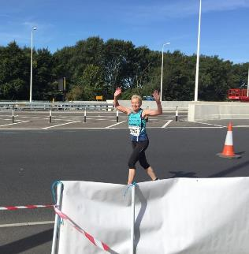

Made our way through Hessle, great support from the crowds, into school where there was another Relay tent, again lots of WHL support which was much needed at this point, feeling a little jaded, ran out of the school and into Pickering Park and back onto Hessle Road towards Gypsyville. Approaching the flyover, no I’m sure it was a mountain, I thought, ‘I’m going to walk up, there’s no way I can run’, then I saw the beautiful Sandra at the top, ‘oh well, better get running’, which I did although I’m sure there was a grimace on my face!

The bit I was looking forward to the most was running through the docks, I was a little disappointed at this though, the subway looked uninviting, dark and creepy (and it was), there weren’t any spectators only a few marshals and the roads had pot holes in them so you had to be careful where you put your feet, this was the bit I was most tired so I would have been more likely to trip, there was also a not so nice smell in this part of the route too making me feel a little queasy! Anyway soon ran out of there passed the Town Crier so now only a mile to go, then the cobbles, ouch, ouch and ouch! Finally the 800m board then the 400m and then the 200m and finally the finish. Was I pleased to see that finish line! 4hrs 13mins 25secs, 2nd lady in my age group (I’ll never be first as first did it 20mins faster than me)! Good for Age. Great day loved every moment.

Special thanks to all WHL’s who were either doing the full, the relays, water station girls (and friends/hubbies) plus our marshals and spectators. A special thank you to Sharron who took some wonderful photos and cheered very loudly! Every single one of you made this happen, you are all stars in my eyes. What a fantastic day for WHL, I am so proud to be a member of this club.

Will I enter next year? We’ll see how London goes!

Jill J “Hull Marathon Experience"
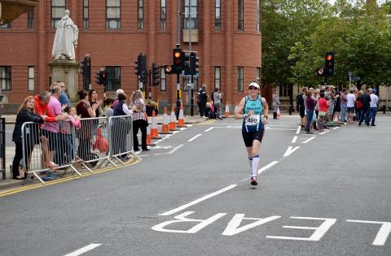

I didn’t actually mean to enter the Hull Marathon, having already done London in April, but I got caught up in the enthusiasm of lots of people entering from the club… and I am so pleased that I did, because it was an awesome event. It was a bit of a family event for me too, as my daughter Kim and my son Mike had also entered as part of a team (Team: Chicken Run), and sister Liz H was doing great work on the whl water station. After the statutory pre-race toilet visit, the start seemed to come around really quickly. I ran with daughter Kim for around four miles at which point she decided that she could go a bit faster than me and ran off. It was nice to see Anna supporting in East Park, and I generally was running amongst various West Hull ladies which was great.

Typically, I nearly chose the relay lane to go down when I got back into the city centre (yes I do confuse left and right…duh!), but fortunately the marshal shouted at me several times and I did eventually go on the correct course. After getting shouted on by Kim who had finished her relay leg, and her co-runner Aimee, who was sporting a chicken inspired face painting, I embarked on the long run towards the Humber Bridge.

It was fab to get cheered on by Maria who was outside the train station, Sharron who was taking pictures down Park Street and then Sandra who was part way up the flyover. By this point I was really looking forward to seeing the whl water station, and the support from them when I collected my water was so helpful. Carrying on up Boothferry road the Red Arrows made their appearance, and it prompted me to have a nice conversation with a woman from Harrogate called Caroline. I was looking forward to getting to Hessle, because I knew this was the halfway point, and I always think that I am then on my way back home (I did contemplate popping in for a cup of tea as I nearly passed by my house, but thought it might mess up my time!).
I was worried about the Humber Bridge because the last time I had run across it had been really hot, but although the sun was out, it wasn’t bad. I actually like double back sections because I like to look for people I know. I saw Amanda on the other side of the Bridge, and then Linda when I was coming off the Bridge and she was going back on. I also caught Jan up who unfortunately was suffering from stitch, and saw Tracy, Ros, Lyn and Liz D. It was also lovely to get some support from Derek from City of Hull, who had given me some marathon advice the week before at the City of Hull Track evening. Going back along the Bridge, I shouted to Verity who was on the other side and I chatted to an East Hull Harrier who was having difficulties with blisters on her feet, and there were lots of people walking at this point. I was pleased to get off the Bridge, but going down the hill on Ferriby Road, was a bit painful on my feet. I actually usually prefer going up hill to be honest.

Into Hessle square I got lots of support from my neighbours who were supporting everyone, and it was nice to see Sarah JW supporting from her bike. I also saw daughter Kim and her boyfriend Kieran (complete with chicken face paint), in Hessle. I found out later that poor Kieran had hurt his knee and had to spend a couple of hours in Sainsburys café (complete with face paint lol!) waiting for us to come and pick him up. By this point I really needed to go to toilet. I had wanted to avoid this if at all possible, after having been traumatized by a portable toilet at the London Marathon, where someone had literally exploded in it, and where I had also dropped my favourite gloves

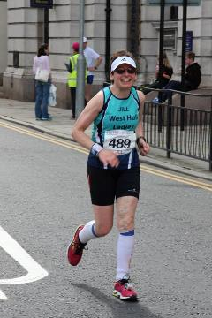

By the time I got to Sirius school, I really did NEED the toilet. I must have shouted ‘Where’s the toilet?’ at every marshal on the site as I went round! Fortunately Jermaine came to the rescue and actually opened the door for me to zoom in…what a relief phew! Feeling better and travelling through Pickering Park, I saw one of the Sunday girls cycle club who gave me a shout, and on Hessle road flyover, up popped Sandra once again, this time with her camera. The next section was through the dock area, and it was a bit bleak and lonely to be honest.

The marshals were great, but I was starting to hurt a bit and lose my form. I was very relieved to come off the dock and when I reached the Town crier ringing the bell, I knew there was only a mile to go.

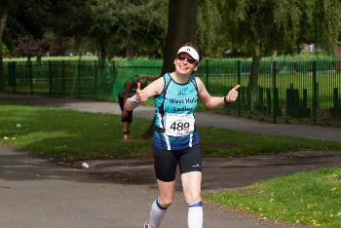
I don’t know whose brilliant idea it was to position the official photographers when we had to run across the cobbles, but the resulting photos were hilarious. Talk about race face…I was really wincing every time I put my right food down (second toe nail was a casualty at this point!), and the photo’s graphically showed this (I won’t be buying those then!). When I came to the sign that said 800m to go, I nearly cried…the emotion really welled up in me. Getting onto Lowgate, I knew that I was nearly back and as I was ‘sprinting’ down to the finish I had this delusional self-image of myself as an athlete of the calibre of Jo Pavey or Paula Radcliffe showing great running style. After watching the finish video however the reality showed me lumbering down to the finish like I had crapped myself!

My sister Liz was stood taking pictures on one of the traffic islands, and heckling me as I ran in (the rotter!), shouting… ’triathlon next week!’ much to the apparent shock of the people around her. Liz then had to explain that we were related so this was only a bit of fun!

After crossing the line and collecting my tee shirt and medal, I was met by Mike, with his guide runner Wayne (who had run the last section in 37 minutes!), and I had a nice hug from the amazing Linda, and Rachael Laughton and her family, and some lovely cake from Ros (Recipe please!). Eventually I met up with the rest of team Chicken run, who had walked from Hessle, due to problems with the shuttle buses. I was really pleased with my run at Hull. Despite the toilet stop, I had knocked around 10 minutes from my London time running 4:22:44. What’s next?…well not another marathon for a bit as I think my body needs a rest after running 2 marathons, two 24 hour races, a half marathon and doing the coast to coast on my bike during the last six months lol! …So that would be a triathlon then!??!!

Amanda "Hull Marathon"
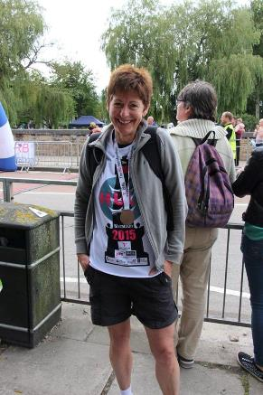
I had been musing over the marathon since getting involved with the organisation back in 2014. However, 2015 was ear marked for testing myself in cycle racing (scary) so I planned to keep my running distances short and did not commit. Then March. Inexplicably I had a bout of plantar facilitis which I could only relate to new trainers. So, no running knocked back.

The ‘M’ continued to mull about at the back of my mind and I even ran a 12 mile off-road with a friend just in case I needed to start building up. My cycle racing was not producing great results so, when a Hull Marathon place ballot at work came up I thought, we’ll let the ballot decide. Before the results came out I ran 15 miles which was really tough, I was not ready for the distance.

The ballot results came and I had a place, it was only 7 weeks to the Marathon far from ideal. I had my cycle training but it was still a lot to expect. My main focus was to get the long runs in but because of the cycling there was not enough time for the miles. My target was 50 miles every fortnight. So, next I ran 17 miles and the last 3 miles were awful. I managed two 20 mile and a 22 mile run, all of which were tough. Even my 16 mile run was tough, I was sure that would be easy. Worse was my 10 mile run which I had to abandon due to a very tight hamstring and hip. None of this was coming easy. I had to hope it would all come together for the day.
The day came, I had rested and felt as ready as I could be but worried about my hip, foot and if I need a comfort break. My Garmin was set to record laps every 5 miles and my plan was to run 8min/mile. Nervous waiting for the starter but once off I soon settled in and felt good. First mile, going too fast (7:16), slowed it down. Nice running through East Park and soon heading back into town. First lap 38:02 so a little too bouncy.
Passing relay station 1 was fabulous, such a big shout of support from our girls. Anlaby Rd then over the flyover where Sandra said I was 8th marathon lady so I was happy with that. Through West Park and Andrea was waiting with my bottle of drink and a gel. Then onwards. My second lap (10 miles) was 39:36 so spot on. Up Boothferry Road and the Red Arrows flew over. Wow!

Heading onto the bridge and the second relay point, another terrific cheer from our ladies and photo taken. Still looking bouncy having just passed the half way point in 1hr 44mins.

My 3rd lap at 15 miles was 42:29, so a little down on my time but this included Boothferry Rd and the drag over the bridge so I should be able to pick up a little as we come off the bridge. This turned out to be wishful thinking. I was still running OK but slow. Far Ings, round the bollard, back over the bridge and nice to see the 18 mile marker.
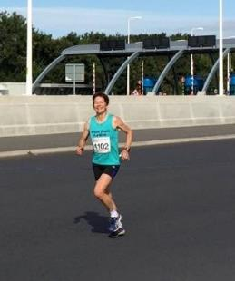
Bouncing over the Bridge.

Down into Hessle and as I ran through the pedestrian section a chap quietly said “Well done love”. That was nice, it was starting to get tough. Mile 20 came 43:09. Bugger I wanted to be faster but now I started to feel sick and if I tried to push on I felt worse. I was digging in but it felt so hard.
- By 22 miles I was never, ever going to run a marathon again.
- By 24 miles I wanted to slap the marshal shouting “Keep smiling”.
- 25 miles and the Town Crier, only 1 more miserable mile to go.
- Trinity Church, 400M to go and I did not have a clue where I was, round the corner and relief, the finish!

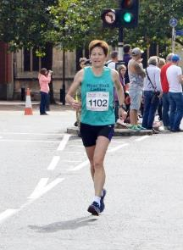
Coming down the finish line, willing myself to the finish, feet barely leaving the tarmac.
I ran through the timers and staggered but Raz (marshal) grabbed my elbows and after a minute I could totter on for my medal, goody bag and a hug from Debbie.

Then to the recovery area and sat down with a drink feeling rather destroyed. The afternoon passed cheering ladies in, pottering, balloons released, chatting and watching finishers.
I waited for the sweeper bus and felt really proud being part of such a well organised marathon and a great route.

Although I did not get the time I wanted it was good: 3hrs 42mins which reflected my training - it is always down to training. I had hoped that along with the cycle training would give me what I wanted but, in the end, if you want to run well you have to train running.

Thanks to all the WHLs who cheered me throughout the race, you were fantastic: Anna (East Park), Relay Station1, Maria (Anlaby Rd), Sharron (Anlaby Rd), Sandra (Anlaby Rd), WHL water station, Ruth (Anlaby Rd), Relay Station 2, Sandra-twice more (Pickering Rd), Relay Station 3, Debbie (finish). I hope I did not forget anyone.

Finally thoughts, “never, ever again?”

(If interested, these two links are reports of what stopped me getting the full marathon training in:
http://htrc.co.uk/2015/04/20/mandys-debut-race-the-barton-australian-pursuit-saturday-18th-april/
http://htrc.co.uk/2015/09/03/my-first-lvrc-racing-season-mandy-dean/ )

Ros "Hull Marathon Experience"
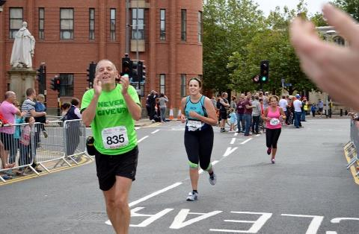
For me this was always going to be an exciting race, with a home crowd and being able to practise the route in training was a first for me and it didn't disappoint. This was my 4th marathon and with each previous one I had overcome problems such as; stitches, blisters and toilet breaks. This one I've learnt to successfully train whilst recovering from an injury and I'm so thankful for the support from fellow club runners, volunteers and supporters.

Right, let's get down to the race, the start and finish area being at Queen's Garden was a great spot to meet up with everyone and take the obligatory team selfie. For the first part I was running with Heidi, I had seen Linda and Jan run ahead at the start and saw Jill running in East Park and realised she had her family running in a relay team and was introduced to her daughter (I can't remember her name, I wonder if she'll be joining the club soon and we'll have the 'Jameson Trio'). Running towards mile 4 the sun was coming out and I was saying, “this is going to be a hot one!” As we headed back into town I saw the second relay change over point and said to Heidi “go for it”, I then heard Lynne shouting “Oy, Barbour-cakes” and Tracy, Lynne and I ran together from mile 6 to mile 25.

The next exciting point was running through West Park and looking out for the club's water stand and our cheering West Hull ladies, it was great to see everyone and a great boost for the next stretch up to the bridge. Passing our relay ladies at the third point was another welcomed boost following the climb up Boothferry road and for me I was feeling nervous heading to mile 16, as this was the point I had to pull out of Windermere marathon and remembering the pain was making me feel very anxious. I'm so glad I was running with Tracy and Lynne as I fear I would have turned into a blubbering mess at this point if I had been on my own and they reassured me I would be ok and I was. At the turning point we saw Jan who was walking due to a stitch and Liz who was looking and running well, we also spotted Rich from City of Hull who was the 4.5 hour pacer and I was thinking “need to get a move on”, as I knew my chance of getting a sub 4 hours 20 minutes was off the cards due to the heat and deep down I wanted to come in under 4.5 hours. Towards the end of the Humber Bridge, the heat was getting to me and I was feeling a little dizzy and I can see from my garmin that I sped up at this point just to get off that darn bridge. Deep down I love running over the Humber Bridge, it's annoying when it's too hot or too wet and windy and sometimes, you get the odd perfect day and it's great. As an iconic landmark for the area, it's inevitable that it would be in a local race. Love it or hate it, you'll end up running over it.

The crowds were great running through Hessle and it had a lovely community spirit to it, as I passed my work (Fire and Rescue Headquarters) I knew there was one last climb over the flyover and before that we had the run around Sirius. This was the only part I didn't enjoy, it felt as though it had been added on last minute for the mileage. It's saving grace was the run through the academy's atrium with it's blaring music that reminded me of the music tunnels at larger races. After the next water stop I needed to walk a bit longer to drink as much water as I could and tip the rest over me, there were only cups so I took two and I think I confused the helper by asking and grabbing them both! At the top of the flyover was Sandra cheering us on, which was awesome and I think I saw her at three different points along the course.

The last bit onto the docks and with one more water stop to go, which seemed to take an eternity to get to, I'm sure Tracy and Lynne must have thought I was lying as I kept saying “we will reach it soon!” It was great to run through a part of Hull that you never get to see unless you work there, but it really did smell and I don't think the sun helped matters. I kept thinking if your race nutrition had gone wrong that this part would tip you over the edge.

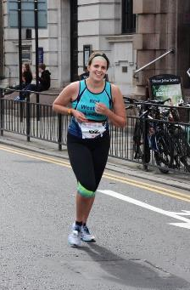

It's always great when you know there's a mile to go and I wished I could have kept up with Lynne and the last bit of cobbles did me in. I saw Jill's face on the photo and it sums it up really, that teeth sucking/screwing up your face at the horror of cobbles. Scarily I heard my left ankle make a loud crack/crunch sound that filled me with dread and I had to stop to stretch it a bit as I couldn't put much weight on it (luckily all is ok). Running towards the finishing line I saw 2 groups of West Hull Ladies cheering all the runners and heard Jill C shout my name and as I looked up I was really confused thinking “why is she 3 feet taller than everyone else!?” Jill C, what were you standing on?

Over the finish line, relief, hugs and photos and then off for a beer. Perfect, thanks to all WHL for being a supportive and awesome club.
Tracy T "Hull Marathon"
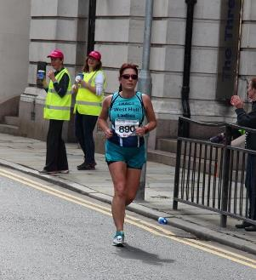

Running a marathon was just one of the many things to do on my bucket list and before I turned 50! However, I never thought that a year after joining WHL I would be running one and in my home city! Approximately 18 weeks before the marathon I started to follow a training plan, good advice received by many of the more experienced runners at WHL, which when looking back I’m so glad I took their advice on board. However, choosing a plan seemed impossible, I didn’t realise there were so many. In the end I choose an Asics plan as it fitted in with my busy life style. I think if I hadn’t followed a plan I would have run either too much or too little, I also believe that the plan prepared my not just physically but mentally as well, it made me realise just how far 26.2 miles really was!

2-3 weeks leading up to the marathon I had to taper, which I found very difficult, I just wanted to get out and run, so again, this is why I was pleased that I followed a plan.
During the last week leading up to the marathon I felt very nervous even to the point where I was going to pull out but everyone kept on reassuring me that I could do and that I’ve worked so hard to get to the point I was at. I received so much support and encouragement from WHL even from those not running the marathon.
The day before the big day I surprisingly felt very calm and relaxed, I think at this point my thoughts were ‘what will be will be’. I wasn’t too hung up about times but in my head I had 4.20 but I told everyone 4-5 hours. The day finally arrived, I was awake at 5am still feeling very calm and relaxed. I got up at 6am to have porridge and coffee and to pack my bag, which included everything but the kitchen sink!
I left home at approx. 7.45am as I was being interviewed by HDM (I think) at 8.15am. I arrived at Hull College with plenty of time to spare, the atmosphere was already buzzing and the weather was perfect.
I was video interviewed at 8.15am, questions included:
- Why did I want to run a marathon
- Was I ready
- How had I prepared
- Had I followed a plan
- What time do I expect to finish

After the interview I walked across to Queens Gardens to look for WHL. I met up with Lynne who was buzzing and like me just wanted to start running. We then met up with all the other WHL, we hugged and wished each other good luck. The aerobics warm up started so a few of us joined in. After the warm up we had a couple of group photos, at this point everyone seemed to be in good spirit. We then agreed that we would all walk to the start together, however some of us went for a nervous toilet visit first. Whilst waiting at the start we had a group hug, I think at this point some of us started to feel a little nervous. Then the race started and off I went with Lynne, we both constantly talked as always. The crowds were cheering us on from the start area, it felt really good to be part of it.

We ran along Holderness Road towards East Park again, the people of Hull were out cheering and supporting us. After the first 6 miles we ran back through the city centre, it was nice to see my husband taking photos from Drypool Bridge. At this point we met up with Ros who had been running with first leg with Heidi, both Lynne and I commented that Heidi looked very strong and that she had completed the first leg in a good time.

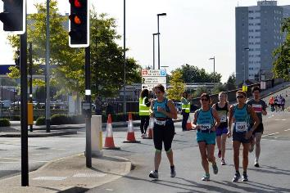

We continued on our journey talking about anything and everything. The atmosphere I parts of the city was electric but then in other parts the support was very little. Running up Anlaby Road through West Park and knowing that my mum and aunty and some WHL were going to be there spurred me on, it was really nice seeing them all. Seeing the Red Arrows fly over was an amazing experience, I did look up and wave but had to careful not to fall over!

We reached the half way point which was at the start of the Humber Bridge, the 3 of us still running together, chatting and supporting each other. At this point I still felt really good and thought to myself that this isn’t that bad really! However, the sun was beaming down on us, it got very hot and the run over the bridge and back seemed to go on forever, we didn’t talk that much for these few miles. I just kept thinking that I wanted to get of this bridge then Lynne said exactly what I was thinking “I can’t wait to get off this bridge!” (I think there might have been a swear word in there somewhere!).

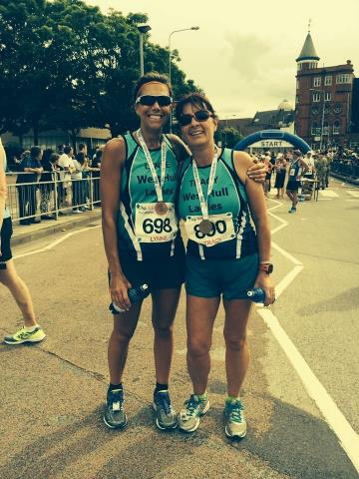

I really was looking forward to last 8 miles going through Hessle, Hessle Road and onto the Docks, however I’d forgotten about running through Sirius Academy and Pickering Park, I really didn’t enjoy this part of the race probably due to the fact that this section had being completely erased from my mind. As we run through Pickering Park I had told Lynne and Ros that I needed to stop, we all walked for a few minutes.

Running over Hessle Road flyover and seeing Sandra was great, cheering us on and telling us how well we were doing. Lynne said “come on girls we can do it, only 4 miles left”. However, at this point I really started to struggle, my head kept on telling me I could do it but my legs really didn’t want to play anymore. When we reached the docks I started to walk/run both Lynne and Ros still looked strong, however they did wait for me at the water station, which I really appreciated as I think I would have walked all the way from there. We had approx.. 1 mile to go, Lynne and Ros said to start running or our legs would cease up. We ran onto the Marina but again I was really struggling, Lynne and Ros telling me I could do it and that if we pushed that little bit harder we would all finish in under 4.30.

At this point I pushed hard, as I was running down Blackfriar Gate/Liberty Lane I heard Rich Harrison shouting “Mrs Tracy Toner I’m behind you” (he was the 4.30 pacer), I didn’t want Rich taking over me so I gave everything I got and pushed so hard, running towards the Guildhall I noticed my husband and son, they were shouting “come on Tracy/mum you can do it, not far to go now” – I felt very emotional at this point. I then heard the crowds cheering and shouting my name then I saw and heard Jill Coupland, which made me smile.

I crossed the finish line at 4.26.16 feeling so really proud of myself. As I crossed the line the HDM guys grabbed me and started to ask me questions, I answered them but for the life of me I can’t remember what my answers were. I became quite delirious and told them that I needed to go as my legs were wobbling! All I could think about was Amanda’s recovery email telling us to keep moving when we cross the line. I then saw Lynne she ran over to hug me and congratulate me. I then saw my husband, son, mum and aunty who all hugged me and said “well done, it’s all over now”. We walked into Queens Gardens as I needed a drink and something to eat.

Over the next 30 mins or so I bumped into so many WHL, again we all hugged and congratulated each other, it felt great to be part of the team. The atmosphere was still buzzing, all those who had finished were elated and so many big smiles.
I found the whole event truly amazing. The organising was second to none, the support from the people of Hull, the volunteers, the marshalls and especially from WHL kept me going throughout.

I was really pleased with my finish time especially since it was my first marathon. People have asked if I could’ve done anything different, thinking about it, I don’t think I could have. I only know that I would never achieved this if I didn’t belong to such an amazing club.

See you all again next year! ☺

Barbara "My First Marathon"

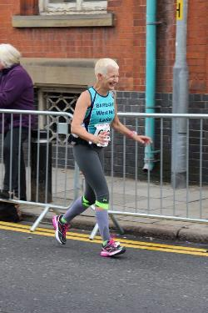

My first marathon was amazing. The support from the crowds and the rest of the ladies was fantastic...I plan to do another marathon definitely...special thanks to Karen Kate Liz Jan Linda.
West Hull Ladies were at the finish line with kind words and hugs and I was very proud to be a WHLon that day.
I did find it hard with the achilles problem but was pleased with my training and thought that had gone well...I even managed to be able to walk downstairs the next day!!!!
xxx Barbara

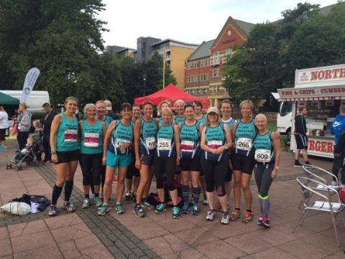
West Hull Ladies out in force
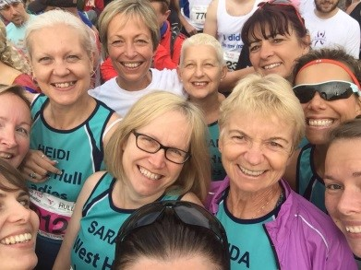

West Hull Ladies: You are all awesome!

Relay Team Runners

Hull Marathon Team Results
43 | 2119 | West Hull Ladies And Laddies | Unisex | 43 | Relay | 43/119 | West Hull Ladies | 03:55:10
72 | 2012 | Cirque De Sore Legs | Unisex | 72 | Relay | 72/119 | West Hull Ladies | 04:07:58
98 | 2017 | Blister Sisters | Unisex | 98 | Relay | 98/119 | West Hull Ladies | 04:36:26
102 | 2093 | Lightening Ladies | Unisex | 102 | Relay | 102/119 | West Hull Ladies | 04:40:43
106 | 2019 | Go On Then | Unisex | 106 | Relay | 106/119 | West Hull Ladies | 04:43:23
107 | 2043 | Sole Sisters | Unisex | 107 | Relay | 107/119 | West Hull Ladies | 04:44:20

Anna
"Go on Then"
Karen, Kristine, Verity and Anna
Not a run report- but a thank you.
I loved being part of the Hull marathon day- and I was only able to be part of it as a runner because I bullied so many of you into joining a relay team! I really appreciated all of you taking part. That’s what makes our club tick- everyone can be involved at their level and is valued for doing so. I felt very proud of everyone on the day!
Thank you for your patience with the organising, I don’t enjoy being bossy! I am now going to enjoy clicking "delete" on my email folder named "marathon". Or maybe keep it ready for next year?!
Thank you again for enabling me to be part of such a brilliant event within Hulls running community.

Sarah C
"Blister Sisters"
Sarah C, Marie, Di and Bev
I ran the first leg of the relay. The crowds certainly carried me for the first mile as I went off a little too quick for me. I reached East Park and saw my two sons and my mum – what a boost to have some one you know and love supporting you! The quick start was taking its toll on me and Ann Holmes passed me in East Park – we said a quick hello and she sailed past me looking really fresh. I carried on and saw Anna – again it was really lovely to see her. The support from the crowds was amazing – I saw several people marshalling from Hull Parkrun and they were so encouraging as I passed through the park. On James Reckitt Avenue again the support was amazing – people shouting out my name, (great idea to have our names on our vests!) I had several conversations with the runners around me and we were encouraging each other on. I turned the corner onto Holderness Road and looked behind me to see 2 sweepers on their bikes – at this point I realised that I was going very slowly so tried to up my pace a little – I grabbed a jelly baby and some water from the East Hull Harriers stand then I saw Karen coming over the bridge to find me! She took hold of my hand and said “we’re going to do this!” and do it we did – Sarah JW also came out to finish the run with me. Holding Karen’s hand & smiling for the photographers we raced to the finish – I managed a little sprint at the end to pass the band onto Marie.
I was very proud to have run in the Hull Marathon and I certainly couldn’t have done it without the support of WHL.
Sarah C
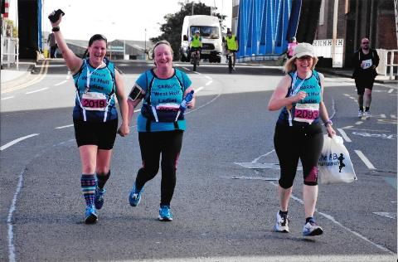

Sarah JW
"Lightening Ladies"
Sarah JW, Jo P, Sarah K, Suzanne
The sun was shining as we all arrived at Queen’s Gardens. I parked my bike at Hull College and made my way to the start, meeting up with lots of other West Hull Ladies as the excitement grew. As a relay runner, I felt a bit of a fraud lining up with the ‘proper’ marathoners, but they didn’t seem to mind! As we set off the sun was getting quite warm, but it was still comfortable. It seemed strange to be running along the roads I drive along so often during my working week, but great to see so many people out supporting the event. As I got to East Park, I spotted some familiar faces, not least Anna, who’d talked us all in to doing the relay, and who was herself running a later leg!
I’d set myself the target of getting the 10k leg completed in under an hour. A time I’d managed in 1 of the 4 other 10ks I’ve done this year, and one that would mean I’d given the other Lightning Ladies the best start I could. As I ran through East Park I was on target, and using Jill as my pacer seemed a good strategy.
Soon we were back on the road, and still there were lots of people encouraging us all. As we headed back towards Queen’s Gardens I seemed to be making good time, but at Drypool Bridge, someone must have put lead in my shoes as that last stretch seemed to take forever! Despite this, according to my Garmin, I made it in under the hour by 5 seconds which I was quite happy with. Having passed the relay band on to Jo, a few of us waited to encourage other West Hull Ladies as they continued on the full marathon, or completed the leg.
Once everyone was in , and as the rest of Lightning Ladies did their legs, I hopped on my bike again, and cycled round the route, updating the team on times and encouraging other West Hull Ladies, although I think they probably thought I was stalking them!
I got back to Queen’s Gardens to see a few West Hull Ladies finishing, and couldn’t help but feel in complete awe of those who did the full marathon. I knew it was difficult before, but now I’ve observed more closely the hours of training involved and the huge effort put in on the day, I am full of admiration. Although everyone was amazing, I was particularly struck by Jill, my pacer on that first leg, who had continued at that pace for the whole marathon. What an athlete! As for Lightning Ladies, our overall time was a very respectable 4 hours and 40 minutes, a great achievement, and one which we all thoroughly enjoyed.
A great day and what a privilege to be a member of this club, and to get the chance to be part of the Hull Marathon! Well done everyone!

Jermaine
"Sole Sisters"
Jill, Rachel C, Beryl and Jermaine
After not doing much running over the summer hols I was a little apprehensive of being on the relay team. Anna had done a fantastic job of keeping us all informed and I was thankful for the meeting she organised so I could get to meet the other ladies in my team - Sole Sisters, Jill Coopland, Rachel Codd, Beryl Parkin and myself. We went for a team bonding run on the Tuesday before the race so that we could have an idea of pace / times.
On the day - I was grateful to Rachael Laughton for giving me a lift to our relay station - Sirius, where we arrived at about 11:30. We were both a bag of nerves and went to the loo countless times. It was a bit weird at the station because we didn't really know where to wait. It was a good place to be though because it meant that we got to see the marathon runners at the 22 mile mark where we could cheer them on! We were also privilege to seeing our wonderful ladies finishing the 3rd and longest relay leg. It was a warm day so standing around wasn't unpleasant. Not sure I would have liked it if it had rained! (nowhere to shelter).
I was jumping & dancing for joy when I spotted Beryl coming around the field and Sarah JW has managed to capture some of my amazing dance moves on camera! (they were worthy of Britain's got talent final!) I was so excited that I forgot to set my watch off at the start, although managed to get it going just before I went through the school. I was pleased that a few ladies stayed at Sirius & were able to give me a cheer as I passed them.
When Di came through she said she had felt guilty passing all the marathon runners and after setting off I knew exactly what she meant, especially being on the last leg. I had fresh legs and therefore passing so many and when the crowds cheered I felt like a bit of a fraud, so couldn't help myself apologising to the marathon runners. I didn't want to dishearten them. The run through the park was lovely and there were also really nice crowds through Gypsyville, lots of kids with jellied sweets, wanting high 5s! I think I high 5'd every kid :D The marshals were great and it was fab to see our brilliant photographer Sandra on the Hessle road flyover. Hitting the docks section was pretty hard. There was just no-one around to cheer, the marathon runners were feeling the pain and lots of them were run / walking, which made me feel bad for them and there was a vile, pungent, stink in the air!!!! I had no idea of whereabouts in town I was but noticing buildings and crowds of people cheering, lifted my spirits and the massive cheers from the WHL on the final straight enabled me to do a decent sprint finish. The official time of my leg was 40:18 which I am happy with.
The marshals at the docks were cheering ' Well done, West Hull Ladies' again!'
Overall I found it a great experience. I am sooo proud of my relay team, they pushed themselves to the limit, neither Rachel, nor Beryl had run their distances before so did amazing jobs. Jill got us off to a fab start. The atmosphere at the relay station was really great. I would encourage anyone who didn't feel up to a full marathon to take part in the relay. Jermaine
Kate B
"Cirque de sore legs"
Heidi, Kate B, Laura and Alison
Like most of us on that race day, our nerves were shot to pieces pre-start. Heidi and I got to Queens Gardens very early; I started to over-think the luggage drop and Heidi generously tolerated my common sense malfunction knowing it was just pre-run jitters.
Heidi got us off to a great start and was pleased with her time – the correct time as recorded by her very reliable time-keeping device. I took guardianship of the bracelet for leg 2 and just ran for the fun of it. The spectators lining the route were all fabulous. They called names and cheered and I felt it made a real difference. The Red Arrows fly over was something else and distracted me from my weariness as I pounded up Boothferry. Not long after seeing the Red Arrows, I passed a competitor carrying a pair of flip-flops; this did not really make sense until I looked down at his feet to see that he was actually running in a pair. Wow!
My leg finished at the Humber Bridge and I handed over to Laura who sprinted off - managing a couple of 8-minute miles before steadying off slightly. Laura did have the longest and quietest leg so team cirque thank her heartily for her excellent contribution.
I stayed for a while at the changeover point and joined in with the shouting encouragement.
Finally myself and a group of WHLs, transited to the City Centre to see Alison and others as they approached the finishing line. We found Sharron with her camera who was capturing some great WHL running moments that we would later enjoy on Facebook. Once again crowd encouragement played a big part, and happily cries of ‘nearly there’ and ‘looking good’ were more or less correct at this point.
The full marathon runners all looked strong and it was clear that their rigorous pre-race preparations had paid off. Alison looked really fresh and practically sprinted to the finish line. Overall, the event was a great WHL experience that I hope to be part of next year.
Kate B.

Marathon marshals and drinks station volunteers
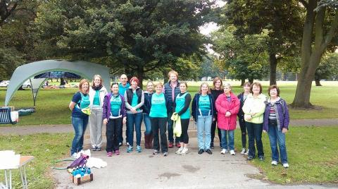

Andrea, Shirley, Debbie, Chris, Sara, Emily, Kate T, Jonathon, Liz A, Liz H, Emma, Maureen, Amy, Joan, Elaine
Liz H
Me and Chris (my husband) set off early as we knew that the water station was due to be set up about 7:15. We decided to drive via Chants Ave as we were not sure if the roads would be closed. On the way we picked up Liz A. When we got to the top end of Chants a squirrel sat in the middle of the road and stopped us, possibly it had a death wish or it could have been a frustrated marathon marshal! Liz made us laugh by saying that she thought it was saying, "I'm from 'ull and I'm 'ard!" We were able to move without harming the said squirrel, and made our way to park at Walton Street.
We walked to West Park and spotted Andrea and Jane struggling with the event tent and picnic table. We caught them up and were able to help them get the equipment to the West Park area, where the water and energy drinks were just arriving. We started to unpack the event tent as more West Hull Ladies started to arrive. After a discussion about the tent we started to put it up, at this point it became clear that all the West Hull Ladies at the drinks station where all the "under tall" ladies and the tent required tall people to erect it! Chris was the tallest person there and he couldn't reach! Luckily at that moment the army arrived in the form of the sector leader, unluckily however he was no taller than any of our ladies or Chris! However he was willing to sit on Chris' shoulders and between them they managed to do it, and for the first time that day I wish I had, had my camera out!
We then turned our attention to the drinks station, we had to mix the energy drinks. We were very concerned that we didn't have enough water and after filling some cups we started to make our way to the ranger station to fill the bottles again. We got the tables full of cups and waited for the runners to arrive. It's quite a good position because you get a good warning and you can see the runners as they enter West Park. At first it's quite easy to give out the drinks but then suddenly everyone arrives together, me and Liz worked together were she handed me the energy drinks so I could keep a constant stream of drinks to the runners. Unfortunately although I was shouting that these were energy drinks a number of runners dowsed themselves with the energy drinks! Every so often a West Hull Lady appeared and although we were encouraging all the runners, the decibels increased. It was great fun to see their faces light up when they saw us. Barbara even managed to give some of our team a hug and we were really happy and surprised to see Ann Holmes come through!
Then an older runner came through and stopped and asked Andrea to fish out an energy gel that he had lost down the back of his shorts! I have to say that our intrepid team leader rose to the challenge magnificently and managed to locate the item and give it to the runner; for the second time that day I wish I had had my camera handy!
All too soon the runners started to dwindle to a trickle and then the two cyclists came through, they told us that there were five runners behind them but in the event only 2 runners made it, one lady telling us she had got lost in West Park. I hope she finished! We then started to pack up and with so many people to help this happened quickly.
When we got home I kind of felt that I had to make my way back into town to support the ladies as they finished, so after a quick cup of tea I grabbed my camera and raced back into town, managing to park across Drypool Bridge. I wasn't sure where I needed to be but could see the crowds and some of the runners as I trotted up. Annoyingly I saw, who I thought was Amanda run, across up ahead but could not take a picture. I knew though that I should get most of our other runners. I positioned myself on a traffic Island with a family who were waiting for their grandad to come through. I was really worried that I had missed everyone and was relieved to see Linda in the distance, I gave her a shout although I think she was, "In the Zone!" and didn't see me. I then saw all the other ladies come through, including Jill, who I shouted to, "Think Linda and don't forget the triathlon next week!" I think the family stood next to me thought I was a bit rude, I explained to them that it is ok we are related! My favourite moment was when Anna suddenly spotted me and gave a little skip, jump and smile and even though I had my camera this time I missed that picture too! I also enjoyed seeing Liz and Jan Draper running together and got a good
picture of them both. I then realized that all our ladies, but Barbara had come through. I went to see if there were any other ladies at the finish and found Karen, Sharon and Andrea so we waited and soon enough Barbara came, we gave her a specially loud welcome and despite her pain she smiled at us and I managed to get a picture!
I really enjoyed the day and am pleased I managed to get some good pictures of all the ladies at the finish, including Amanda who looked awesome in her marathon T shirt and with her medal. I will be involved next year I hope, either as a volunteer or runner. It was also great to get a marathon maker t shirt, a nice touch from the organizers I think!

Liz H
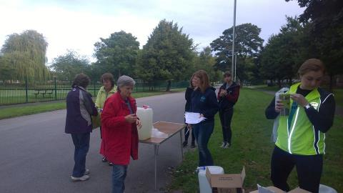

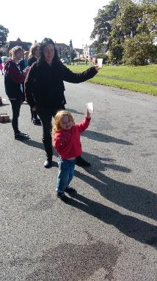
Annette & Xanthe giving out drinks

Sandra

I volunteered initially with my daughters Amy and Emma to help at the water station at West Park.
In all honesty I really didn't want to do this initially as I wanted to get out on the course and cheer the runners on. I thought it would hinder me doing this.
Anyway as things turned out the day before the marathon marshals were still needed and so I volunteered for that instead on the proviso I was near West Park.
So on the Sunday morning I was up at 6am - I initially intended to cycle to West Park but then thought better off it - what if I got a puncture? - excuses excuses.

So the bike was loaded in the car and I set off to West Park. Kate T was already there waiting with a friend and soon other ladies followed. I went to the meeting place for Zone 14 and was allocated Anlaby Road flyover - this was quite a spot as I was only there as a 'visual' for the runners. There was no traffic for me to concern myself with.

The runners soon came into sight and it was wonderful - I had a few comments from members of the public baffled as to how I knew the names of most of the athletes taking part. They were also staggered at the distance they were running and it did seem a long way as I described the course. So I had a great time clapping and cheering. It was just wonderful to see all the West Hull Ladies running past - looking relaxed happy and with beaming faces.
After the last runner went through I waited anxiously to get the order to ''stand down" - I was wasting time stood in a street with no runners. My daughters contacted me to say they were finished and they had enjoyed working with everyone at the drink stations. They thought it was funny runners had been pouring energy drink over their heads - oops!

Eventually word came that we could stand down so I was off on my bike. I went onto Hessle Road near Asda - then to Pickering Park and Sirius Academy. I was impressed with the support along the way. It was a lovely day and I was able to have a chat with many supporters. I saw many West Hull Ladies - Amanda being the first coming out of Sirius Academy. And then Linda looking so at ease. It was great to see so many of you and all looking so good.

I eventually decided to go onto the Hessle Road flyover - the last 'hill' on this flat marathon course! and the 23 mile mark. It is really hard being a supporter as you can soon say the wrong thing - by now many people were beginning to flag but the race at that stage was really in the bag. I was stood with a guy whose daughter was running her first marathon. She was running with the 4.30hr pacer. It was good to reassure him she would be alright with Rich Harrison to run with - and she did pass us with a beaming face.

So most of the Club ladies went past - Jan and Anna stopped for a quick hello and photo! Barbara then came and she was suffering with an achilles problem. That was the hard bit knowing that whatever you said you couldn't take the pain away. But at the time being so proud at the determination shown by everyone had to finish.

After I saw Barbara turning off towards the docks I went back to where it all started for me West Park. My hands were so sore from clapping and when I got home I felt like I too had run a marathon. I was at the doctors the next day - I had tonsillitis!

So all I can say is thank you so much ladies for running the Hull Marathon and giving me the opportunity to have a wonderful 'proud' to be a member of a great club day. It was brilliant - fab, fantastic ............See you next year

Sandra
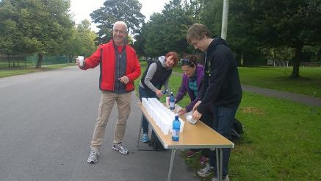

Andrea

It seemed like such an easy thing to do, volunteering to help out at the drinks station (easier than running a marathon!) and a great way to be a part of things. As the day came closer and the emails from the organisers started coming in on a daily basis, realisation dawned as to how important the drinks stations are, and how it could go horribly wrong. I had visions of tripping up runners, running out of water, poisoning everyone with incorrectly mixed energy drinks etc etc! Fortunately due to the wonderful group of people who volunteered to help man the station none of my fears were realised.

Bright and early at 7am I picked Jane up and we made our way to West Park. Actually the only reason I offered to pick Jane up was so that she could help me carry the WHL event tent from the car to our spot in the park. And she did a marvellous job. We saw Liz A, Liz H and Chris on the way in and they helped too. (Thank goodness) Jane then made her way to her marshal point and I think we had an easier time of it than she did.

Very quickly we started setting up the station. I was torn between getting the drinks ready too early, and ending up with flies in them, and running out of time. Fortunately we decided that we should get everything done as early as possible and were ready for the runners by about 9 which was when he race started.

We were able to see the lead bikes and the first runners entering the park, which gave us a couple of minutes warning, soon enough they arrived. The team leapt into action, some at the front of the tables handing out the drinks, some at the back keeping the supplies coming. We were like a well-oiled machine. I was hopping about in a panic trying to record the numbers of the first few male and female runners so that I could report back to the commentator at Queen’s Gardens so that he could keep spectators updated there.

Fortunately Rachel A had come to help out (although she is still recovering from her recent operation) and was able to shout out the numbers to me. I was also keeping a watch out for Amanda, Linda and Lynne as I had their gels and drinks and I was worried about missing them too. I managed to pass Amanda and Linda their supplies without incident, however Tracy T who was running with Lynne decided that she would take Lynne’s drink – I left them to argue it out between them, I wouldn’t have been able to keep up anyway.

The largest group of runners passed and the numbers started to thin out. Towards the back I saw Bob Thomson a man in his 80s who regularly runs Peter Pan parkrun. He stopped for a chat and a drink and quite calmly asked if I would get him a gel from the pocket at the back of his shorts. The rest of the group found this very amusing as I fished about looking for the specific orange flavoured one. I didn’t realise that this was part of the duties I’d signed up for, but as he then went on to win his age category I think I’ll take some of the credit!

As we had so many volunteers we managed to get cleared up really quickly, and I was able to get into town to see most of the runners cross the finishing line. It was quite an emotional experience to see all the runners cross the line in various states of pain, elation, some limping, some out sprinting each other at the finish line, many joined by their children clearly proud of their mums and dads. I was particularly proud of all our West Hull Ladies and really enjoyed cheering you all over the line.

Thank you to all the volunteers on our drinks station who helped out in any way; to Liz A, Liz and Chris H, Debbie, Roger and Charlie, Kate T and her sister Maureen, Tracy T’s mum Joan and her aunty Elaine, Sandra’s daughters Amy and Emma, Kate B’s husband Jonathon and their daughter Emily, Shirley, Sara, Annette and Xanthe (who was a fantastic tidy upper) Sally and Rachel A – and to Jane for helping carry the event tent! (I hope I haven’t forgotten anyone!) A huge thank you to all of you – our contribution was really appreciated by the organisers. We really worked well together and I really do think we were the best drinks station!

Andrea

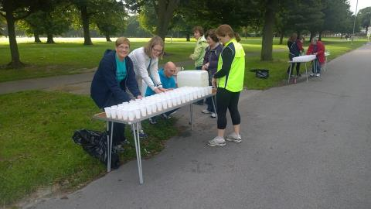
Lining up the drinks

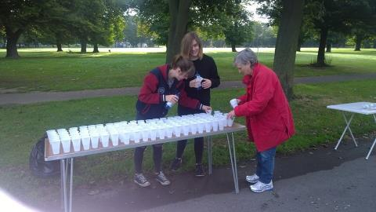

Ruth

I volunteered my husband and myself to help at the WHL water station in West Park, but when we found that the water station had plenty of helpers, we swopped to volunteering to marshal.

This actually suited me very well because the marathon goes past the top of our street, so all we had to do was go to the training for volunteers at Hull College one evening, and walk to the top of our street on the big day. What could possibly go wrong? Well, for starters, we had to be at Tesco Express on Anlaby Road at 7.30!! 7.30!! On a Sunday!! And on Saturday evening we discovered that we had a ‘plumbing emergency’ which meant that Dyno Rod would be visiting our house to do the necessary sometime between 08.00 and 16.00 hrs on Sunday. Hubby volunteered to stay at home. Good, because I was looking forward to marshalling.

At 7.30 I turned up at Tesco Express. 2 people already there: Beryl’s husband and a lady called Catherine who had started the last WHL 0 – 5 k, but had to drop out and was determined to attend the next one. Other people turned up; one lady doing a half marathon in a couple of weeks or so, and her daughter, and then Jane. Jane had taken the difficult decision to marshal, difficult because she had been planning to run in the marathon, and cheering other people on when you couldn’t do it yourself must have been hard. We ended up with a motley crew of 11, not good when our organiser had been expecting 22.

We sorted out marshalling positions and settled in to wait. Initially we just moved ‘road closed’ signed for confused drivers and gave them details of alternative routes, and when the road would be fully closed etc. About 09.50 the road was closed, some spectators turned up and the runners started coming through. I really enjoyed cheering them on, (especially WHL ladies) and hoped I was helping them a bit. After they had all gone through we moved a few cones, and I was home for 11.30. Job done.

I had only a couple of run-ins with drivers (one of which was defused admirably by Beryl’s husband), but I understand some other marshals had a torrid time.

I’d love to do it again next year, and would hope that, if the marathon is run again next year, the date and the route are not changed. People then know what to expect, and drivers would hopefully be more understanding. As someone pointed out (I think it might have been Sharron) marshalling a marathon is a lot easier than running it.
Ruth

Post Marathon Recovery Drinks at Pave

Jan
Ever the social animal, I thought it would be a great idea if we could celebrate the Hull Marathon by having drinks at Pave. I had been struck by the way in which the marathon organisation and preparations had brought different people across the Hull running community together. So it seemed right to extend an invitation to everyone across Hull who had been involved, in whatever way, in making the marathon such a success – solo runners, relay runners, supporters, marathon makers, goody bag packers, organisers…

Even though I had warned Pave there might be a surge in business (they had put on extra staff just in case!) I had no idea how many people would actually arrive. So it was great to see so many people, turn out, some in their marathon tee-shirts. It was also nice to have a drink bought by my daughter – a rare occurrence! (Only joking Liz!).

Drinks, banter, informal chatter, hugs, hot flushes, numerous marathon post-mortem discussions, advice about next marathons, promises never to run any more marathons (!), it was just so nice to have time socialising, relaxing and to see each other in non-running gear!

The photos were not very good quality (I have promised to get myself a better camera!) and I know I missed a few people, so sorry girls!

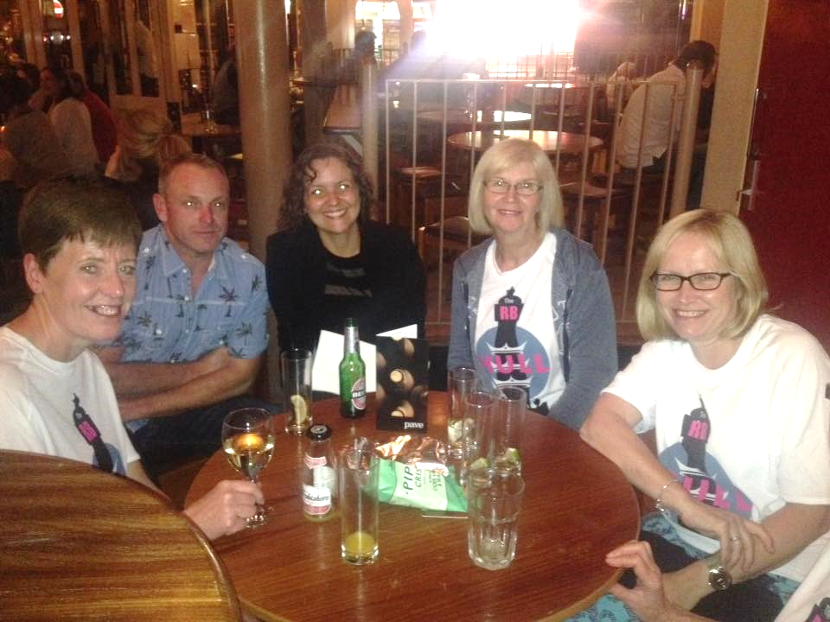

We must do this more often! Go out drinking that it is, not necessarily running a marathon!

Linda

So after the excitement of the marathon Jan had organised us to meet up at Pave for anyone who wanted to come along in our special T-shirts and chat about the day.
So Sarah JW and I went together, lovely to have company driving from South Cave and we could chat about our day as we were both still buzzing.

Quite a lot of us was there and so were some runners from White City, it was lovely to chat to everyone and share our experience of the day and have a little drink together. Thank you Jan, great idea of yours.

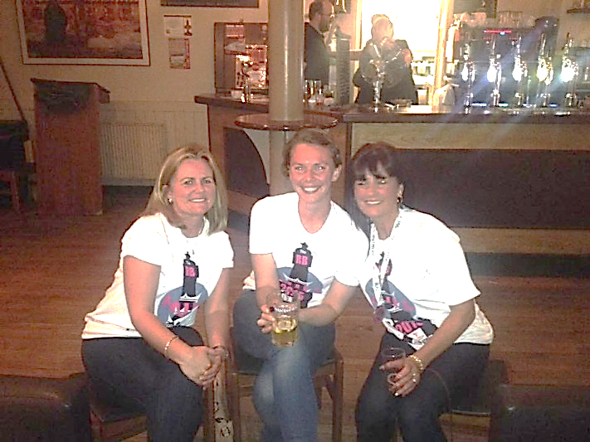

Amanda

Marathon over, had tea (couldn’t eat a lot). It was lovely to walk down my street to Princes Ave and meet the girls in Pave. A large glass of red wine, comfy leather settee, chatting and reflecting on what a brilliantly run marathon and what a brilliant part West Hull Ladies played.

Was fairly exhausted so was in the emotional state of “We are just amazing, our water station was amazing, our marshals were amazing, Hull was amazing, our marathon ladies were amazing, the relay runners were super amazing” (still makes my tummy go a bit when I think of the cheer from the relay station as I ran past). I was even thinking “I do OK” and feeling a little proud of myself. Thank you Jan for organising. It finished off a fab day perfectly.

